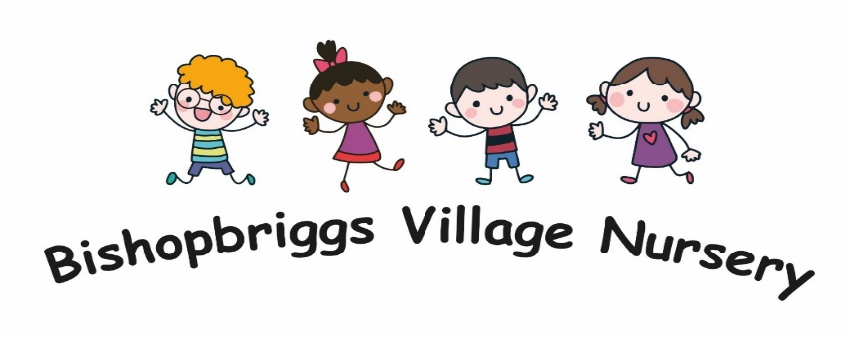
Our Vision, Values and Aims
Our Vision
Our vision at Bishopbriggs Village Nursery is to provide an environment that is safe, nurturing, happy, stimulating and fun in order to get it right for every child, fostering curiosity, independence and a love of learning.
Our Values
At Bishopbriggs Village Nursery we value
- Fun
- Kindness
- Respect
- Inclusion
- Nurturing
- Communication
- Partnerships
Our Aims
- To ensure high levels of wellbeing for our children and staff
- To deliver a curriculum through play-based learning facilitated by a committed and skilled staff who respond to children’s interests and needs.

Nursery Information

Name Bishopbriggs Village Nursery
Address 21 Park Avenue Bishopbriggs, G64 2SN
Telephone 07908065079
E-mail administrator@bishopbriggsvillagenursery.co.uk
Website bishopbriggsvillagenursery.co.uk
Facebook @BBVNursery
Twitter @BBVNursery
Denominational Status Non-Denominational
Capacity We currently have 24 places for children aged 3-5 years
Care Inspectorate Registration CS2003003641
Scottish Charity Number SC006583
Session Times 08:30-14:30 Monday-Friday
Nursery Year August-June Term Time

Bishopbriggs Village Nursery offers early learning and childcare for children aged 3-5 years. We are long established in the area and pride ourselves on our reputation and service. We are a voluntary sector nursery with charitable status. We work in partnership with East Dunbartonshire Council offering fully funded 1140 hrs places.
The nursery has a management committee of volunteer parents and carers. The committee employ the staff. The nursery manager oversees the day to day running of the nursery and of managing the staff team.
Our recent move to Park Avenue in Bishopbriggs has greatly improved our environment offering a wonderful natural light filled space and direct free flow access to our private outdoor space.

Staff

Heather Graham Nursery manager BA Childhood Practice
PDA Childhood Practice
HNC Childcare & Education
NC Childcare & Education
Lindsay Drennan Depute SVQ 2&3 Social Services(C&YP)
Lynn Petrie Early Years Practitioner PDA Level 8 Childhood Practice
HNC Childcare & Education
NC Childcare & Education

Michaela Deanie Early Years Practitioner HNC Childhood Practice
Emma Barrett Early Years Practitioner HNC Childhood Practice
Kirsty Woodley Kitchen Assistant

All staff are members of the Protecting Vulnerable Groups scheme (PVG) - Protecting Vulnerable Groups (PVG) scheme - mygov.scot
All our childcare staff are registered with the Scottish Social Services Council. This is a requirement of employment which is renewed yearly - The Scottish Social Services Council - Scottish Social Services Council (sssc.uk.com)

Enrolment, Registration and Admission

In the first instance please contact the nursery to enquire about spaces and access the waiting list.
The waiting list operates as follows:
- Names can be placed on the waiting list at any time by contacting the Nursery Manager and by then completing and returning a waiting list form
- Names are added to the list in order of the date on which the initial contact with the nursery is made
- Nursery places are offered to the children in strict order of the date on their waiting list entry form each registration year and according to the following criteria
- Where there are insufficient places to meet the demand, the following criteria will come into force:
- Children identified and referred to the Nursery as having a particular need will be given priority over strict adherence to the waiting list
- Priority will then be given to children with older siblings already attending the nursery
- Priority will then be given to children in their pre-school year living within East Dunbartonshire Council
- Priority will then be given to ante-pre school children living within East Dunbartonshire Council
- Priority will be given to children who will be using the fully funded hours at the nursery
- Children resident in other council areas may be allocated places only after all applicants from the East Dunbartonshire Area have been allocated places. This is in accordance with the Council’s Early Years Admission Policy.

The waiting list will be monitored to ensure that all sections of the community are being reached and to ensure no discrimination is taking place on grounds of ethnic background of children in the nursery.
Having a child’s name on the waiting list does not guarantee a place at the nursery

**The staff are here to help and guide you through enrolment, registration and applying for funding so don’t hesitate to contact us **

Registration & Admission
You will be invited to a registration/open day event at the nursery during the January registration period. This provides an opportunity for you and your child to view the nursery, meet staff and discuss the registration process.
When you are allocated a place in our nursery you will be informed by letter from East Dunbartonshire Council. When the nursery receives this information, you will be contacted by the nursery who will give you a starting date and details of settling in visits.

Settling In
Settling in is an important stage in the transition between home and the Nursery, or between one setting and another. The nursery aims to make this a smooth transition by:
- Giving the child and their carer time to familiarise themselves with the environment. A parent/carer must be present during settling in due to our insurance.
- Offering a warm and welcoming environment and ensuring each child feels included, secure and valued. Health and Social Care Standards: 1.9,1.10,1.11
- Recognising each child as an individual and his or her readiness to leave the parent/carer and adapt to the new environment. Getting it Right for Every Child
- Sensitively dealing with parents/carers readiness to leave their child
- Providing strategies to help parents/carers to work with staff during the settling in period. The Parental Involvement Act (2006) identifies the key role carers play in a child’s life and highlights the importance of carers and staff working together
- Staggering intake of new children into the setting
- Providing familiar play and learning experiences. No child will be taken on an outing or visit until he/she has settled.
- Providing feedback to parents/carers about how their child is progressing and supporting them through the settling in period
- If a child does not settle and is unhappy and distressed at being in the setting the child’s key worker will discuss with the parents/carers the best way forward for the child and the family.
(Health and Social Care Standards: 3.1, 3.4, 3.5, 3.6, 3.7, 3.8, 3.9, 3.10, 3.11, 3.12, 3.13)
There will be paperwork to fill in during this time. You will be asked to provide personal details and information about your child and yourselves. Confidentiality of information will be respected in line with The Children and Young People (Information Sharing) Scotland Bill (2017) which allows information sharing with the carers permission to ensure support is in place where required for the child and their family. A child’s plan is required for every child using a nursery. The information you provide and share is vital in ensuring smooth transition and the best possible care and learning outcomes for your child.
(Health and Social Care Standards: 1.23, 2.14)

Starting Nursery

The day has come, and your child is starting at Bishopbriggs Village Nursery (funding begins the day after your child’s 3rd birthday. Should your child’s birthday fall during a holiday funding commences the first day following the holidays.)
At the settling in visits a start time will be given to you.
We are fully aware it will be a day full of differing emotions as your child takes these first steps. Hopefully the above procedures will lead to a smooth transition. As always staff are there to not only support your child but you too so, please don’t hesitate to chat to us or ask any questions.
You will find a handy checklist and top tips at the end of this handbook.

Confidentiality & General Data Protection Regulation (GDPR)
Bishopbriggs village nursery recognises that the safety and well-being of children and families is of paramount importance. All information, verbal or written, we will be treated confidentially and the privacy of those involved in the nursery will be respected. We require to hold information about the children and families and staff working within the nursery and systems will be in place regarding the sharing and storage of this information. Parents will be able to share information in confidence knowing it will only be used to enhance the welfare of their children. However, we cannot withhold confidential information regarding the welfare of the child and this information will be disclosed to specified personnel and agencies if required. Parents will be made aware of this enrolling their child to the Nursery. Throughout the guidance the term parents will be used to include all caregivers.

General Data Protection Regulation (GDPR) and Data Protection Act 1998 (DPA)
General data protection regulation (GDPR) came into effect on 25 May 2018 and expands on the current regime establishment by the data protection act 1998 (DPA). Please refer to the Nursery’s privacy policy for more detailed information.
We adhere to the principles of both regarding the use of personal information and follow the relevant principles:
- Information must be used fairly and lawfully
- Information must be used for limited, specifically stated purposes
- Information must be used in a way that is adequate and relevant
- Information must be accurate
- Information must be kept safe and secure and kept for no longer than absolutely necessary.
There may be legal reason for data to be given to an agency or the care inspectorate.
Children’s Records
The nursery keeps records of the children including:
- Personal records
- Online learning journals
Personal records will record information including registration and consent forms, contact information, correspondence from other agencies regarding the child and or family, health issues and any other relevant, confidential information. These records will be stored securely in a lockable cabinet. Parents will have access only to their own child’s file.
Online learning journals may include samples of the children’s work, photographs, observations of the child’s progress. The journals are password protected and will be accessed and contributed to by only staff and the child’s family (see separate Learning Journal procedures).
All information regarding children and/or their families will accurate and up to date and shared only with the appropriate personnel. Children’s personal details cannot be passed on to another person or people without the parent’s prior knowledge and consent. Committee members, staff and adult helpers do not talk publicly about matters relating to the children and their families. Staff do not discuss children, other than for curriculum development and nursery management purposes, with any other person/s without the parent’s knowledge and consent.

Child Protection
***If you believe that a child is at immediate risk of significant harm, please contact Police Scotland on 999.***
You can also discuss concerns about a child by contacting:
- East Dunbartonshire's Advice and Response Team - 0141 777 3000
- Out of Hours Social Work Standby Service - 0300 343 1505
- Childline - 0800 1111
- Scottish Children's Reporters Administration - 0131 244 8201
- NSPCC - 0800 800 5000
- Police Scotland – 101

Bishopbriggs Village Nursery is committed to improving the life chances of children in our care. We acknowledge that the child's welfare and wellbeing are paramount and that we have a duty of care to implement effective policies and procedures for safeguarding our children.
Our policy provides guidance for all setting staff and follows the National guidance for child protection in Scotland 2021. For ease of reference, we will use the term ‘the guidance’ when referring to this document throughout the policy. The sole focus of this policy is the protection, safety, and welfare of children and young people includes unborn babies, and children and young people under the age of 18 years. Throughout this guidance the term ‘parents’ is used to include all main caregivers and the term ‘staff’ is used to include all volunteers and students.
As we are in partnership with East Dunbartonshire Council (EDC) we follow their procedures regarding Child Protection (CP), (Child Protection | East Dunbartonshire Council) and we actively take part in their CP training.
The National guidance for child protection in Scotland 2021.This non-statutory Guidance describes the responsibilities and expectations for all involved in protecting children in Scotland and replaces the 2014 version.
It outlines how statutory and non-government agencies should work together with parents, families, and communities to prevent harm and to protect children from abuse and neglect.
The Guidance promotes partnership between those who care about and have responsibilities for the child, and entails a collaborative approach between professionals, carers and family members.
A key change in the 2021 Guidance is to reflect the greater integration of child protection within the Getting it right for every child (GIRFEC) continuum and use GIRFEC language and core components to frame identification and proportionate responses to child protection concerns within the National Practice Model.

Family Learning, Parental Involvement and Parental Engagement
We truly believe that parents are the first educators of their children and have the greatest effect on their lives. To achieve the best outcomes for the children at Bishopbriggs Village Nursery (BVN), we strive, and are proud of, the relationships we forge with the families and parents. We are partners with the families and parents in their child’s journey through their early learning and childcare experience.
The ways in which we involve and engage are highlighted below. We refer to the Realising the Ambition (RTA) document, the national practice guidance for Early Years in Scotland, for the definitions.
Family Learning - “Family learning encourages family members to learn together as a family, with a focus on intergenerational learning. Family learning activities can also be specifically designed to enable parents to learn how to support their children’s learning.” (RTA, 2020, 59)
How we foster this?
- Curriculum days
- Focused visits
- Lending library
- Home learning bags
Parental Involvement - “Parental involvement describes the ways in which parents can get involved in the life and work of the ELC or school setting” (RTA, 2020, 59)
How do we foster this?
- Membership of the Management Committee
- Parental questionnaires
- Face to face conversations
- Volunteering
Parental Engagement
‘Parental engagement is about parents’ and families’ interaction with their child’s learning.’ (RTA, 2020, 59)
How do we foster this?
- Contact/communication – face to face, newsletters, emails.
- Learning Journals
- Formative and summative communications
- Parents meetings
- Home visits
If you are interested in joining the management committee, please speak to a member of staff and we’ll point you in the right direction.

Curriculum
Within Bishopbriggs Village Nursery we recognise the importance and value of high-quality early learning and childcare. We are committed to providing a stimulating and challenging environment which will develop and broaden children's learning experiences, leaving them confident, eager, highly motivated and disposed to learn more. We aim to be responsive to each child's individual needs, including any additional support needs, and to build on the child's prior learning and natural curiosity.
The importance of play in a child’s development can never be overestimated and we believe that through play children can discover vital learning skills, gain confidence and a greater understanding of life.
Children are a vital aspect when planning for the nursery. The staff spend time with the children, we talk to them, observe them in their play and always listen to what they have to say. According to UNICEF " Every child has the right to be heard."

National Guidance
We will be guided by Realising the Ambition: Being Me. The guidance builds upon the original principles and philosophy of Pre-Birth to 3 and Building the Ambition. It explores the range of interactions, experiences and spaces we need to provide for babies and young children to help them learn and grow best from their earliest days through to being a young child in early primary school.
We will be guided by Curriculum for Excellence: early level. We embrace the values inscribed on the mace of the Scottish Parliament (wisdom, justice, compassion and integrity) which underpin Curriculum for Excellence.
Our aim is to nurture each child's capacity to become
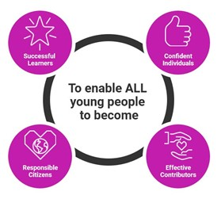
  - Successful Learners
  - Confident Individuals
  - Responsible Citizens
  - Effective Contributers

Curriculum planning will follow the design principles of:
- Challenge and enjoyment
- Breadth
- Progression
- Depth
- Personalisation and Choice
- Coherence
- Relevance

Curriculum content will be driven by the experiences and outcomes for early level described in Curriculum for Excellence within the broad curriculum areas of:
- Health and wellbeing
- Languages
- Mathematics
- Social studies
- Expressive arts
- Religious and moral education
- Sciences
- Technologies
The principles and practice guidance within each of these curricular areas will support our understanding of subject importance, structure, progression, assessment and its relevance within the wider curriculum. We will use this guidance to inform our role in delivering the curriculum.
All children have a right to a broad general education and although our curriculum will be driven by children's needs and interests, we will ensure that they have access to a wide range of experiences across all curricular areas.
Scottish Government has identified health and wellbeing, literacy and numeracy as key areas of learning and development for all and we will ensure that opportunities to foster learning and skills in these areas permeate our curriculum and all aspects of the Nursery's life.
Seasonal activities and the celebration of festivals will form a backdrop to our planning as appropriate, rather than the key focus of learning, which will be dictated by children's needs and interests in conjunction with the guidance above.

Reporting to Parents & Access to Information
Each child will have their own online learning journal which will showcase their learning as it takes place in the Nursery. It will follow the Curriculum for Excellence. These journals will have photos, videos, observations and pictures of their artwork. Staff will work on the journals with the children and their learning experiences will be sent to you during the term. You will also have the opportunity to share any of their achievements and learning that happen at home or away from the Nursery. Information evenings will be held for new parents when staff will explain how the journals work including examples and answer questions. This can be done one to one for those unable to attend.
Staff will use continuous assessment and record keeping throughout the year including observations during the normal planned and free play activities in the Nursery. This will enable us to complete a ‘Settling In Progress Report’ shortly after each child has started Nursery and a ‘Communication Report’ which you will receive at the end of terms 1 and 3, each year. This will provide a brief summary of how your child is progressing through the three main areas of the curriculum, together with the next steps in their learning. Both you and your child have an opportunity to comment on their progress on these documents. Your child’s Settling In Progress Reports and Communication Pages will be included in their online journal.
At the end of your child’s time at Nursery a ‘Transition Report’ will be completed using information gathered through observation and assessment, and this Report will be passed on to your child’s Primary School to ease transition.

Supporting all children through Personalised Support
We comply with The Education (Additional Support for Learning)(Scotland) Act 2004 and (Additional Support for Learning) (Scotland) Act 2009 which places a legal duty on Childcare services to identify, assess and support children with Additional Support Needs.
All children require support to help them learn. However, there are some children who require extra support and are deemed to have Additional Support Needs (ASN). The needs can be short term e.g. if there has been a family bereavement or parental separation. For other children their ASN will be longer term e.g. speech
and language difficulties, hearing impairment, physical disability, learning difficulties. In all cases, the child’s key worker and/or Manager will work closely with parents/carers to support and care for the child.
Through working in partnership with East Dunbartonshire Council (EDC), we follow the authority’s Personalised Support process to identify, assess and support the learning needs of all children.
Key features of Personalised Support are as follows:
- The ASN of all children is addressed through the Personalised Support process, regardless of the origin of these needs
- Support can be Universal, Targeted or Targeted Intervention
- The level of support required to meet a child’s needs is provided in a way that is the most appropriate and least intrusive to the child
- Planning for individual children is part of the process for planning for all children
How we do this
- Through Observations we measure all children’s Wellbeing and Involvement.
- If there are concerns about a child we look at how we can address these within the centre.
- If these concerns remain the child will be included in our ‘Support for All’ (SfA) discussion.
- At this stage we liaise with Parents and the child’s Named Person i.e. Health Visitor to ensure all relevant information is shared.
- Regular SfA meetings are held throughout the year in line with GIRFEC and EDC’s guidelines. From time to time your child may be discussed in relation to Universal Support which may lead to Targeted Support. Senior Nursery staff, our EDC Early Level Support Teacher and a representative from Health (usually a Health Visitor) attends. Identified next steps will be shared with parents.
- If appropriate a Team Around the Child (TAC) Meeting may be arranged to discuss your child’s individual needs, to which you will be invited to attend.
If you require further information please arrange to speak to our Nursery Manager.

Getting it Right for Every Child (GIRFEC)
Getting it right for every child (known as GIRFEC) is the national approach intended to make sure that all the people who support your child work together seamlessly to give you and your child the right help at the right time. (Parentzone Scotland)
Whenever your child needs help or support, GIRFEC aims to make sure that both you and your child:
- feel confident about the help being given
- understand what is happening and why
- are listened to carefully, with your wishes heard and understood
- are appropriately involved in discussions and decisions that affect you
- can rely on appropriate help being available as soon as possible
- experience a fair and co-ordinated response from staff.
Important elements of GIRFEC are:
- The approach helps services provide high quality support to all children and young people (aged 0-18) and their families including a clear point of contact for children and families to go to for initial support and advice. This point of contact if often called a named person, but different terms are used across the country.
GIRFEC is about wellbeing
GIRFEC focuses on eight areas of wellbeing that are important for your child to grow and develop to reach their full potential. These are:
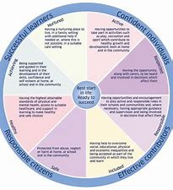
- Safe
- Healthy
- Achieving
- Nurtured
- Active
- Respected
- Responsible
- Included.
At Bishopbriggs Village Nursery we introduce the concept of GIRFEC and the wellbeing indicators to the children through the Sid & Shanarri programme ( http://sidandshanarri.co.uk/)

United Nations Convention on the Rights of the Child
The UNCRC is the 'gold standard' across the world for children's rights. It covers all aspects of a child's life and sets out the civil, political, economic, social and cultural rights that all children everywhere are entitled to. It also explains how adults and governments must work together to make sure all children can enjoy all their rights. (gov.scot)
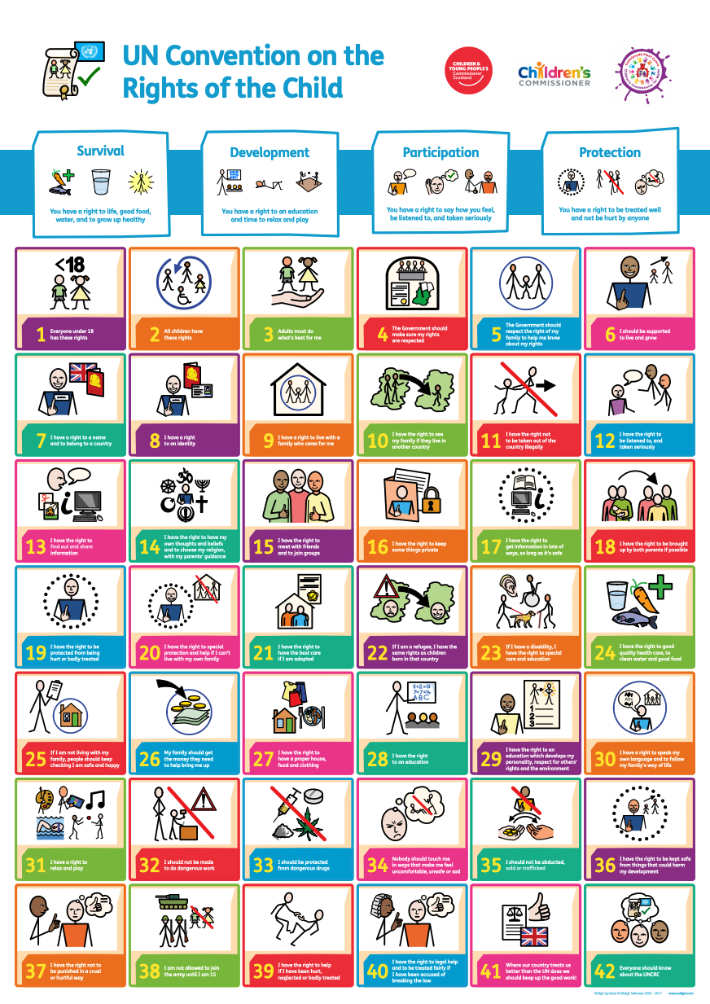

Equality and Equity
Equality - Equality is defined in legislation and is designed to make sure every person has an equal opportunity to make the most of their lives and talents

Equity - Equity is a policy concept and approach that aims to focus on treating people fairly and providing additional or different support where required. Equity in education means that personal or social circumstances are not obstacles to achievement and that all children and young people are well supported and have the same opportunities to succeed
connect.scot

Bishopbriggs Village Nursery welcomes and respects all children, parents, staff, professionals and other members of the local community and will not discriminate against them on the grounds of their race or ethnicity, their disability, their gender or sexual orientation, their age or religion. Our aim is to be inclusive and to celebrate positively the rich diversity in society. We are committed to promoting equality of opportunity for all. We are a free at point of service setting and provide snack, lunch and milk for all via government schemes. No child will ‘miss out’ while at nursery due to family financial circumstances.
The Equality Act 2010 makes it illegal to discriminate against a person on the grounds of their race or ethnicity, their disability, gender or sexual orientation, their age or religion. We will exercise due regard to the need to eliminate unlawful discrimination, advance equality of opportunity and foster good relations.

Nursery Life
This section contains important information in relation to the day-to-day involvement of you and your child in the nursery.
Uniform
The nursery offers a uniform of red polo shirts £6 and red sweatshirts £7. These are available to buy through the nursery. The uniform items are not compulsory.
Nursery can get messy, and the children can get messy as they learn and discover. With that in mind we advise comfortable clothes that are not deemed as ‘good’. Accidents do happen.
Please dress your child appropriately for the weather.
Separate indoor shoes are also required. We suggest ones with a hard sole as in an emergency we may have to leave the building in these. We also advise that shoes with laces only be provided if your child can tie them themselves.
Wellington boots and waterproofs are required in order to facilitate year-round outdoor play and learning.
If there are any issues in providing these items, please speak to the nursery manager.
We would discourage the wearing of jewellery that could cause injury or harm to your or another child. The children are very active at nursery. Bishopbriggs Village Nursery are not responsible for the damage or loss of any jewellery.
***PLEASE MARK ALL CHILDRENS BELONGINGS WITH THEIR NAME***

Attendance
If you area aware your child will be absent from nursery please notify us as soon as possible this can be done in the following ways-
- Telephone – 07908065079 (The phone is manned Monday-Friday 08:00-15:00 term time)
- Email – administrator@bishopbriggsvillagenursery.co.uk (Emails will be answered during nursery hours)
- Speak to a member of staff
Nursery is open from 08:30. If we have not been notified of absence by 09:15 the nursery will contact you by telephone. PLEASE ENSURE ALL CONTACT NUMBERS AND PERSONS ARE KEPT UP TO DATE.
While nursery start time is flexible from 08:30 it is beneficial if your child arrives as close to this time as possible.
Arrival and Collection of Children
Children should be brought to and collected from nursery by a responsible person over 16 years old.
Each morning staff will ask and note who is collecting your child. If the situation arises where someone we have not met before will be collecting, they will be asked to provide the password that you have given to nursery during settling in. It is your responsibility to pass on the password to your helpers. If the person collecting has never been introduced to us at the nursery we will ask you to send in a photo via email.
If you are dropping off late or collecting early please notify staff.

Arrival Routine
- You are welcome to come down to the bottom gate at 08:25 where a member of staff will greet you at 08:30. PLEASE DO NOT OPEN THE GATE TO THE NURSERY OUTDOOR SPACE FOR SECURITY REASONS, STAFF WILL DO THIS.
- It is essential you walk your child down to the bottom gate and do not send them unattended as staff will require information from you and may have information to relay to you.
- If you are arriving after 08:45 please ring the bell at the top gate to alert staff.
Collection Routine
- Children can be collected from the bottom gate. We close at 14:30.
- Again, if you are coming earlier, please ring the bell at the top gate to alert staff.
- If you arrive early without having previously notified the nursery, please note it may take time for your child to get ready to leave
- Please arrive on time. Children can get anxious. Obviously unexpected incidents happen. If this is the case notify the nursery ASAP by telephone.
The nursery has policies for Unidentified Absences and the Late Collection of Children.

Snack and Lunch
Children have access to a healthy snack during the morning. Water and milk are available to drink. Snack is on a rolling basis where children can choose and serve themselves and enjoy some social time with their peers.
A hot lunch consisting of 2 courses is provided to children. At lunch all the children sit together, using real cutlery and crockery and clearing their utensils by themselves when finished, promoting and encouraging independence.
The lunches are prepared off site and delivered to the nursery each day shortly before lunchtime.
All staff have Elementary Food Hygiene Certificates.
If your child has an allergy, intolerance or follows a special diet it is imperative that you let us know so that we can cater for their needs. We ask that you do not give your child any food or sweets to bring into Nursery to protect children with allergies.
Medication
If your child is on or requires medication, please speak to the manager ASAP.
Illness
If your child is ill do not send them to nursery, they may be better at home until they feel well.
If your child has a high temperature they should not attend nursery.
If your child has sickness and/or diarrhoea, they cannot attend nursery. Your child can return to nursery 48 hours after the last bout of sickness and/or diarrhoea.
If your child becomes unwell at nursery, we will contact you via telephone.
Covid
Covid regulations are constantly changing. The nursery will notify you of the most recent.
If your child has a fever, they cannot attend nursery. If your child has symptoms of covid the current advice is to be Covid safe and stay at home.
Injury and Accidents
Staff will record any injuries or accidents in the Accident book and a copy will be given to parents upon collection of their child.
First aid trained staff will treat your child within their limitations
If a child sustains a head injury, we will contact parents via telephone. With the information provided by staff the parent will decide whether to collect their child immediately or at finishing time.
Fees
Unfunded children will be charged a daily session fee. The fee is set each year at the Nursery AGM in August.
Payment of the fee will be arranged with the nursery manager.
Mobiles
The use of mobile phones are not permitted in the nursery without the consent of the manager.
Please do not take photos of the nursery, outdoor space or children.
Smoking
Smoking – cigarettes, e-cigarettes or vaping – is not permitted in or on the nursery grounds
Complaints
Bishopbriggs Village Nursery is committed to providing a high-quality service and maintained good relationships with parents. It is important that staff and parents work together in the best interests of the children. At times, however, things can go wrong, or misunderstandings may occur. Complaints will be dealt with fairly and confidentiality.
- In the first instance please contact them manager regarding your complaint. If the complaint relates to management, contact the chairperson of the management committee.
The care inspectorate is the national organisation which regulates and inspects care services. The care inspectorate has a complaints procedure for dealing with any complaint regarding regulated services. If you wish to complain to the care inspectorate further information can be found in the complaints section of the care inspectorate website – www.careinspectorate.com
Our Care Inspectorate registration number is – CS2003003641
We are inspected by both the Care Inspectorate and Education Scotland. The most recent reports can be found on their websites – www.careinspectorate.com – www.education.gov.scot.
Emergency Closure
- Should the nursery need to close unexpectedly during the day parents/carers will be contacted by staff via telephone to arrange safe collection of your child.
- If for any reason the nursery is evacuated and we are unable to return we will make our way to St Matthews Primary School, Park Road, Bishopbriggs, G64 2NP. Nursery staff will contact you via telephone to arrange safe collection of your child.
- If for any reason the nursery is unexpectedly unable to open, staff will contact you via telephone and post on the nursery social media channels.

Top Nursery Tips!
- We cannot stress enough how important it is to put a name on everything that your child has for nursery. Labels, stickers or written in pen! Any way to allow us to identify items.

- Nappies & wipes – if your child requires these please ensure you provide us with a supply.

- Velcro, Velcro, Velcro! Velcro shoes are best for their indoor nursery shoes. It promotes independence for the children allowing them to easily change their own shoes. Also think about the shoes they come to nursery in. Can they do the zip? Can they tie laces? As you can imagine with 24 children in the nursery if they all had lace up shoes that they couldn’t do the staff would spend a huge portion of the day just tying laces!

- Coat or jacket. Please ensure your child brings one everyday or even a zippy or hoody in the warmer months. The children love to be outdoors at any time.

- Spare clothes – Nursery is messy (lots of fun which can equal mess). Please provide us with at least 2 spare changes of clothes for your child. All labelled of course! If your child is toilet training please increase the amount of spare clothes.

- Remember – wellies, waterproofs, indoor shoes with a hard sole.

- It is recommended that your child wears sun cream from March to September. Please apply this before coming to nursery. A sun hat that can be kept in nursery is also recommended.

- Unsure or wondering about something? Just ask! We are always available to answer questions and queries.

- With that in mind we ask a lot of questions. It’s not that we are incredibly nosey it’s just that the more we know about your child and their family the best possible care we can offer. It also helps us to build a positive relationship with our families.

- Please ensure we always have your up to date contact information.

